AI IMAGE GENERATION

Create an image of field of flowers using DALL.E, Deep Dream and DeepAI.

DALL.E

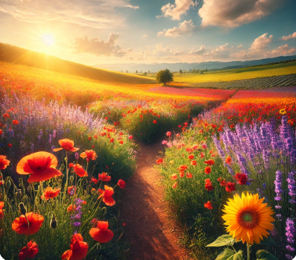

DALL·E is a powerful AI tool designed to generate images based on text descriptions. When you ask DALL·E to create something like a field of flowers, it aims to produce an image that looks as lifelike as possible. It creates a photo like realistic scene.

The flowers would appear vibrant, with distinct, well-defined petals, stems, and leaves, giving the impression of a real flower field. The sky above would likely be clear and bright, and the light would interact with the scene in a realistic way, casting gentle shadows on the ground and reflecting off the petals.

Deep Dream

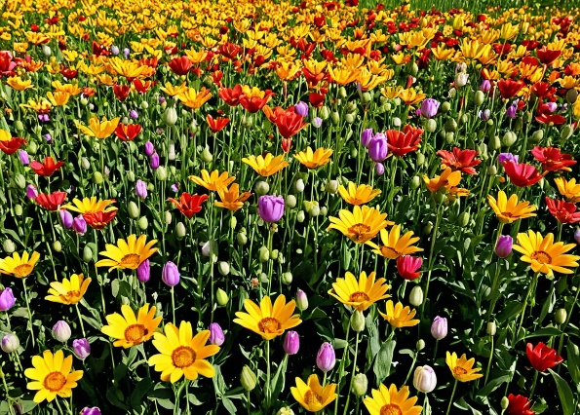

When you ask Deep Dream to generate a field of flowers, the results would be dramatically different from a realistic depiction like DALL·E.

The flowers in the field could appear warped or transformed, with strange shapes or even distorted patterns that repeat and evolve across the image. The end result is not something you’d typically find in nature. Deep Dream is designed to push beyond the conventional limits of perception, creating an image that feels more like a visual trip or a hyper-realistic interpretation of what the AI sees within the flowers creating an entirely new and almost unsettling version of a field of flowers. It's a striking, highly stylized take on reality.

DeepAI

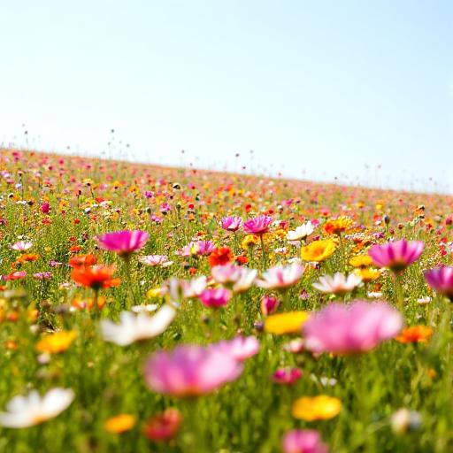

DeepAI is a platform that leverages machine learning models to generate images from text descriptions. Its approach to image generation is often more flexible and artistic compared to purely photorealistic models like DALL·E. When you ask DeepAI to generate an image of a field of flowers, it combines both realistic elements and artistic abstraction.

The flowers in a DeepAI-generated field may still be recognizable such as sunflowers, tulips, or daisies but they may not look exactly like they do in real life. Instead of sharp, clear outlines and precise details, the flowers might have a slightly blurred, dreamlike quality that conveys emotion and atmosphere rather than strict accuracy.

**Which tool is best?**

* If you're after **realism** (like a photo of a field of flowers), **DALL.E** is the go-to tool.
* If you're looking for something **surreal and imaginative**, **Deep Dream** will create a unique interpretation.
* If you're more interested in a **stylized or painterly** image with some artistic abstraction, **DeepAI** would be the best fit.